8/10/2025

Milestone # 1

Robotics (Edpt1009) W’21 course project

Robotics (EDPT1009) Word Document Template

Project Milestone: MS# 1

Team Number: # 14

**Title of the milestone (Ex. Modeling and Control of Poppy Humanoid Robot)**

Nada Ehab, Martin Morcos, Ibrahim Amr, Abdelrahman Khaled, Mohammed Oasama, Mohand Mohamed

Literature Review:

Robotic arms have become an essential component of modern automation, driving innovation across medical, industrial, agricultural, and service sectors. Advances in control systems, sensors, and artificial intelligence have enhanced their precision and versatility, enabling tasks ranging from surgery and rehabilitation to manufacturing, harvesting, and logistics. This literature review explores recent research on robotic arm applications across these fields, highlighting key developments, challenges, and trends shaping the future of automation.

The medical field has seen a significant integration of robotic arms, enhancing precision, enabling remote procedures, and improving patient care. One of the most innovative applications is in the field of 3D bioprinting, where robotic arms are used to fabricate biological tissues. A 2023 paper by Li, et al.describes the use of a 6-DOF robotic arm in 3D bioprinting for cartilage and vascularized cardiac tissue regeneration, showcasing the potential for creating complex, customized biological structures [1]. Another critical area is telerehabilitation, where robotic arms assist patients in their recovery process remotely. A 2022 study by Modi, et al. introduces an interactive telerehabilitation system that uses a 5-DOF robotic arm integrated with an IIoT platform [2]. This system allows therapists to guide patients through upper limb rehabilitation exercises from a distance, using an augmented reality interface to control and monitor the robot's movements. This technology not only makes rehabilitation more accessible but also provides a consistent and data-driven approach to therapy. The COVID-19 pandemic highlighted the need for robotic solutions to ensure the safe and accurate control of biomedical equipment, minimizing human exposure to infectious environments. Iadanza, et al. (2023) designed, prototyped, and tested a robotic arm capable of interacting with common-use interfaces and medical equipment keypads [3]. This innovation aims to protect healthcare workers and the public by enabling remote operation of critical devices, thereby reducing the risk of contamination and infection during health crises.

Industrial automation remains the most established domain for robotic arms, where they are employed for a variety of tasks to improve efficiency, precision, and safety. A 2022 paper by Dzedzickis et al. discusses the evolution of industrial robotics, from classic robotization strategies to the adoption of collaborative robots (cobots) [4]. Cobots are designed to work alongside human employees without the need for safety cages, enabling new forms of human-robot collaboration in manufacturing and assembly lines. The simulation of robotic arms is also a crucial aspect of industrial applications, allowing for the planning and optimization of robotic tasks before deployment. A study by Long, et al. demonstrates the use of MATLAB and its Robotics Toolbox to simulate a robotic arm for industrial applications, highlighting the importance of simulation in designing and validating robotic work cells [5].

Robotic arms are increasingly being adopted in agriculture to address labor shortages and improve the efficiency of farming operations. A 2020 paper by Morar, et al. presents a robotic system for cucumber harvesting, demonstrating the potential for robotic arms to perform delicate and repetitive tasks in agriculture [6]. Robotic arms are increasingly used in agriculture to improve precision and reduce labor demands. Mohapatra et al. [7] developed and tested a multi-DOF robotic arm for crop handling and fruit picking. The system performed efficiently under field conditions, showing that robotic manipulators can enhance productivity and consistency in modern farming.

The service sector is a relatively new but rapidly growing area for robotic arm applications. As seen in the medical field, robotic arms are being integrated into service robots to perform a variety of tasks. A 2021 review highlights the use of mobile robots with manipulator arms, such as Moxi and Poli, for tasks like delivering medical supplies, personal protective equipment (PPE), and laboratory samples in hospital settings [8]. These applications reduce the workload on healthcare professionals, minimize the risk of contamination, and improve overall efficiency in hospitals. In addition to this, robotic arms are also being developed for direct personal assistance. Abubakar (2020) introduced ARNA, a mobile manipulator designed to assist nurses with tasks such as patient walking and sitting in hospital environments [9]. This demonstrates the growing trend of robotic arms providing direct physical assistance in service roles, improving efficiency and reducing the physical strain on human caregivers.

The reviewed literature demonstrates the expanding role of robotic arms across a diverse range of sectors. From the high-precision requirements of medical bioprinting to the robust demands of industrial manufacturing and the delicate touch needed in agriculture, robotic arms are proving to be versatile and indispensable tools. The emergence of robotic arms in the service sector, particularly in healthcare, signifies a shift towards more human-centric applications. As AI and robotics technologies continue to advance, the capabilities and applications of robotic arms are expected to grow, further transforming industries and our daily lives.

**Proposed Project Application**

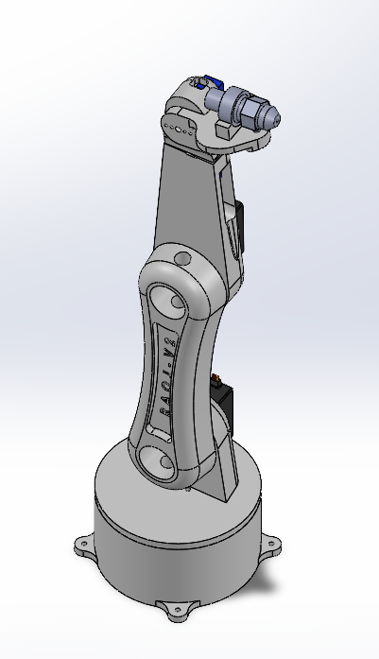Our proposed project involves the development of a robotic arm system specifically designed for car painting applications. This robotic arm will be equipped to hold a car painting spray gun and execute precise, pre-programmed movements to apply paint uniformly on a car surface. The system aims to enhance efficiency, consistency, and safety in the car painting process, reducing human exposure to harmful chemicals and ensuring a high-quality finish. This application leverages the precision and repeatability inherent in robotic arm technology, similar to industrial manufacturing processes, but tailored for the specific demands of automotive finishing.

**List of Components Needed**

1. Servo Motors x6.

2. Microcontroller (Raspberry Pi/Arduino).

3. Nozzle as an end effector.

4. 3D printed robotic arm.

5. Wiring & Connectors & Power regulators.

5. Spray bottle (Total).

6. Hose.

7. Power supply.

8. PWM driver board if needed.

**References**

[1] K. Li, J. Zhang, L. Xu, and X. Chen, “Advancements in robotic arm-based 3D bioprinting for biomedical applications,” *Life Medicine*, vol. 2, no. 6, pp. 1–16, 2023.

[2] P. P. Modi, M. S. H. Sunny, M. M. R. Khan, H. U. Ahmed, and M. H. Rahman, “Interactive IIoT-based 5DOF robotic arm for upper limb telerehabilitation,” *IEEE Access*, vol. 10, pp. 114919–114928, 2022,

[3] E. Iadanza, G. Pasqua, D. Piaggio, C. Caputo, and S. Rossi, “A robotic arm for safe and accurate control of biomedical equipment during COVID-19,” *Health and Technology*, vol. 13, no. 1, pp. 1–10, 2023.

[4] A. Dzedzickis, J. Subačiūtė-Žemaitienė, E. Šutinys, U. Samukaitė-Bubnienė, and V. Bučinskas, “Advanced applications of industrial robotics: New trends and possibilities,” *Applied Sciences*, vol. 12, no. 1, p. 135, Dec. 2021,

[5] D. T. Long, T. V. Binh, R. V. Hoa, L. V. Anh, and N. V. Toan, “Robotic arm simulation by using MATLAB and Robotics Toolbox for industry application,” *SSRG International Journal of Electronics and Communication Engineering*, vol. 7, no. 10, pp. 1–4, Oct. 2020,

[6] A. Morar, “Research regarding the development of a robot for harvesting cucumbers in protected crops,” *IOP Conference Series: Materials Science and Engineering*, vol. 997, no. 1, p. 012081, 2020,

[7] S. Mohapatra, M. R. Panda, and P. K. Nayak, “Development and testing of a robotic arm for agricultural applications,” *AgriEngineering*, vol. 3, no. 1, pp. 192–205, 2021.

[8] J. Holland, M. H. A. Hameed, and H. A. Jalal, “A review on mobile robots in hospitals,” *Robotics*, vol. 10, no. 1, p. 47, 2021.

[9] S. Abubakar, “ARNA: A service robot for nursing assistance,” in *Proc. 2020 IEEE Int. Conf. on Robotics and Automation (ICRA)*, 2020, pp. 9216845.